Name :Mohamed Ahmed Abdelaziz ID:211005016
Test Case 1: GitHub API
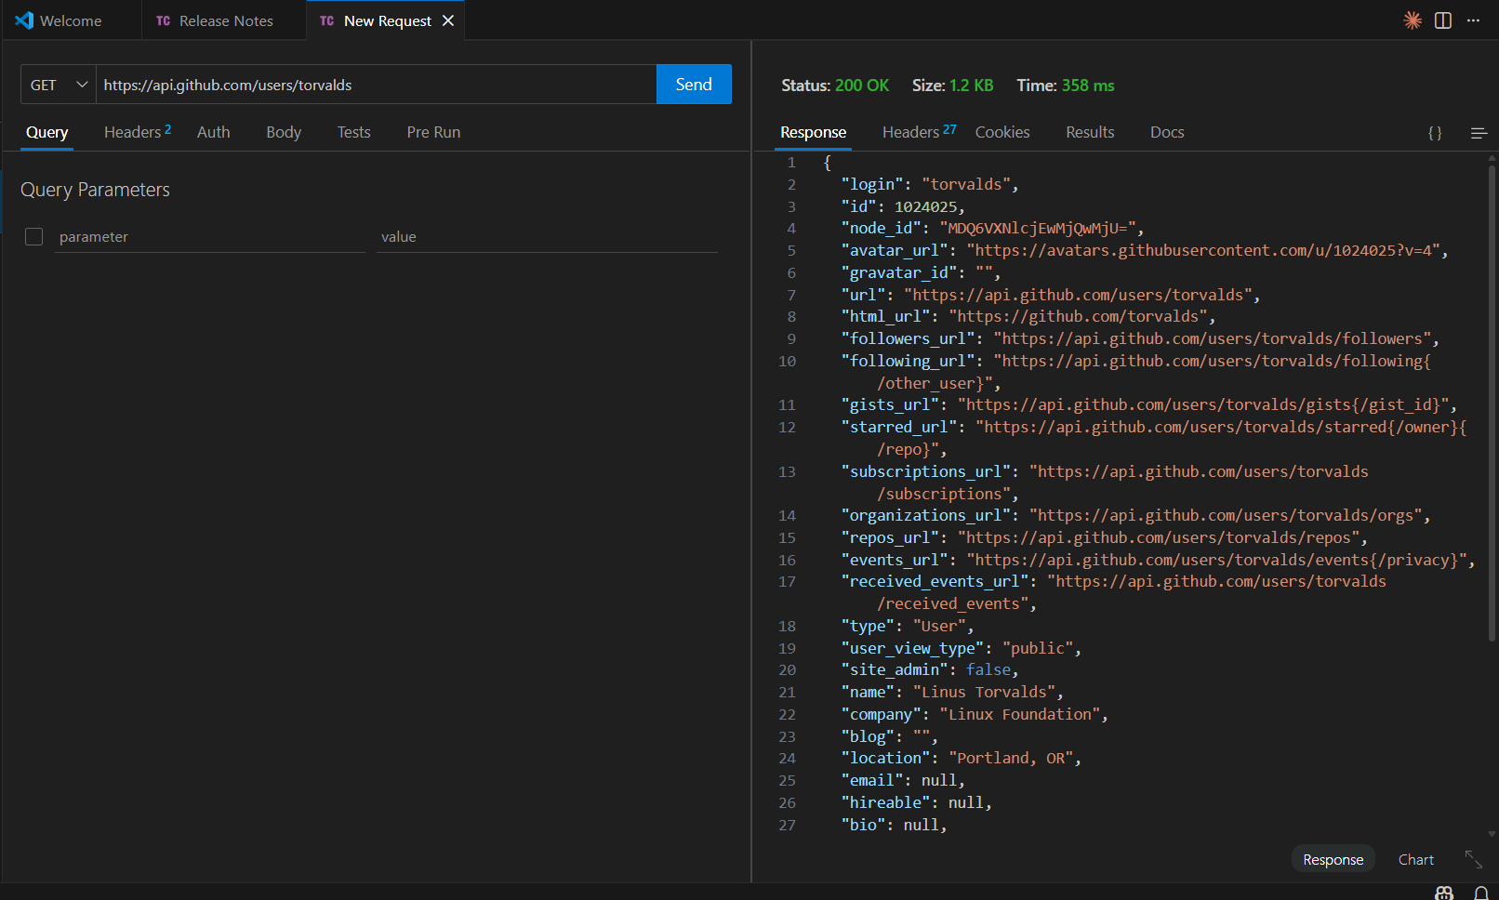
Explanation: Successfully retrieves public GitHub user information. Status 200 indicates successful retrieval of the user profile.
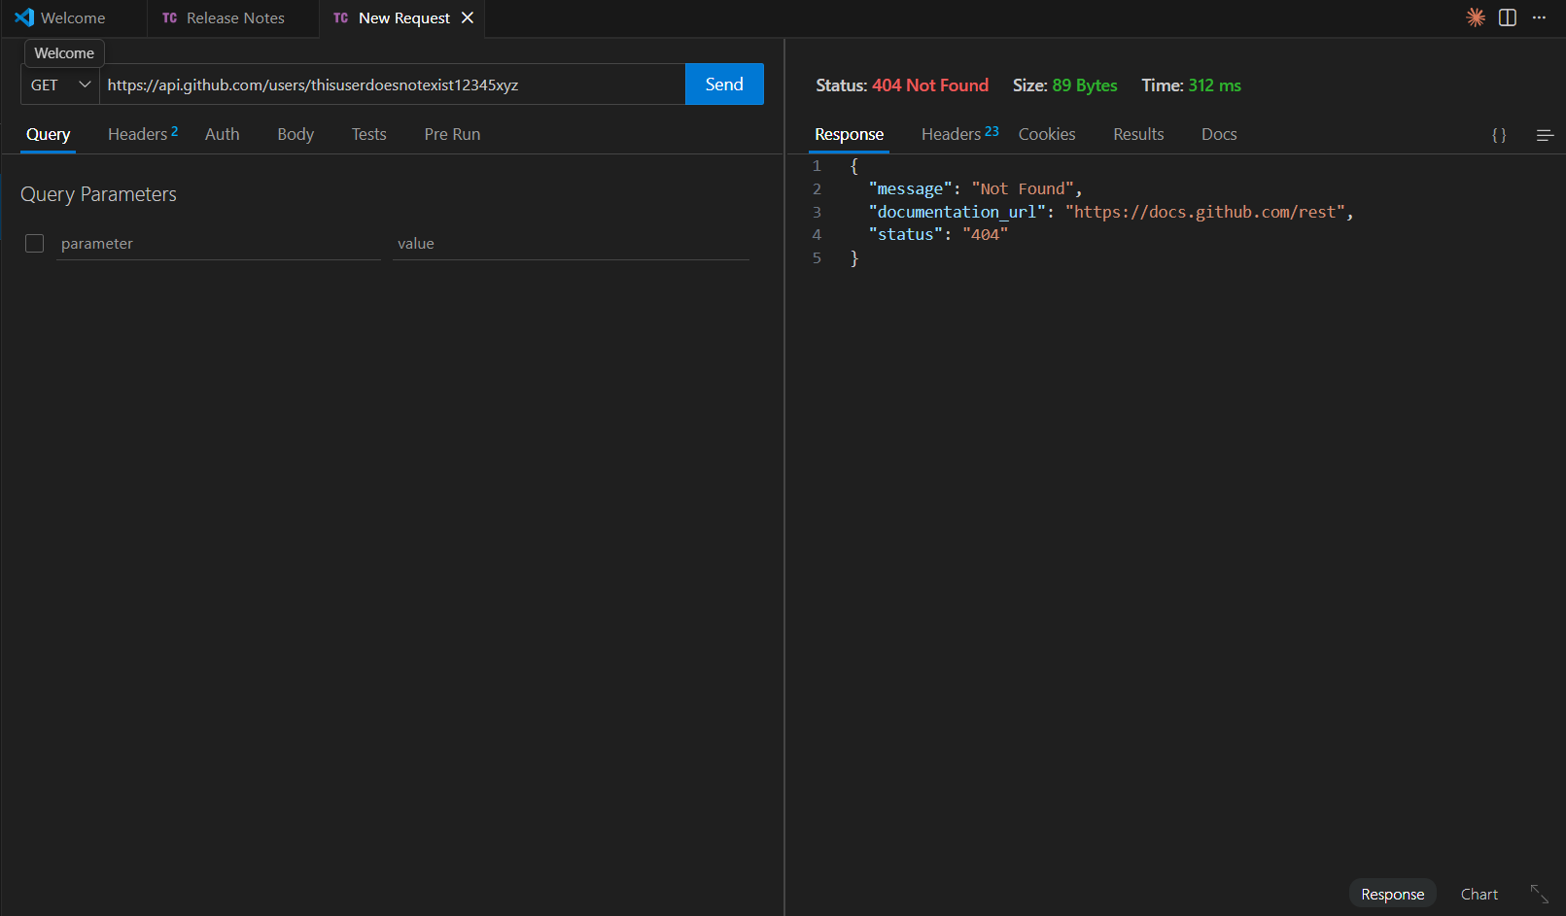
Explanation: Returns 404 when requesting a non-existent GitHub user, properly indicating the resource doesn't exist.
REST Compliance Analysis:
Follows REST Conventions

- Clear resource hierarchy (/users, /users/{username}/repos)
- Uses GET for data retrieval
- Supports pagination through headers
- Proper HTTP status codes
- JSON response format
- RESTful URL structure

Test Case 2: REST Countries API
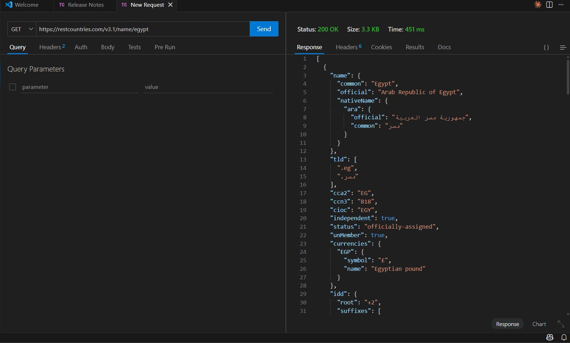
Explanation: Successfully retrieves information about Egypt. Status 200 indicates the country data was found and returned
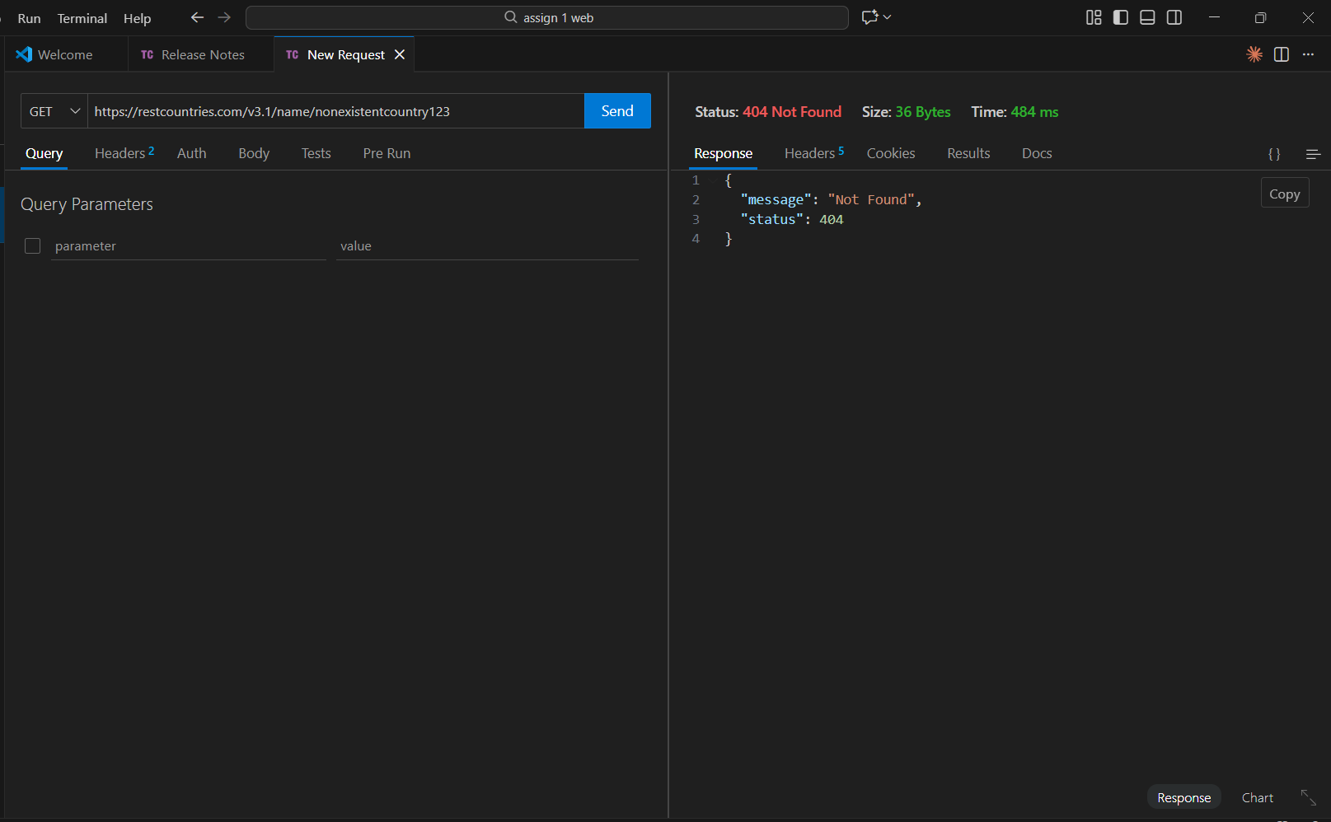
Explanation: The API returns 404 when searching for a country that doesn't exist, properly indicating the resource wasn't found.
REST Compliance Analysis:
Follows REST Conventions
- Clear resource-based URLs (/name/{country}, /alpha/{code})
- Uses GET method for retrieving data
- Returns appropriate status codes
- Stateless requests
- Standard JSON response format
- Supports filtering and querying through URL parameters
Test Case 3: NASA API
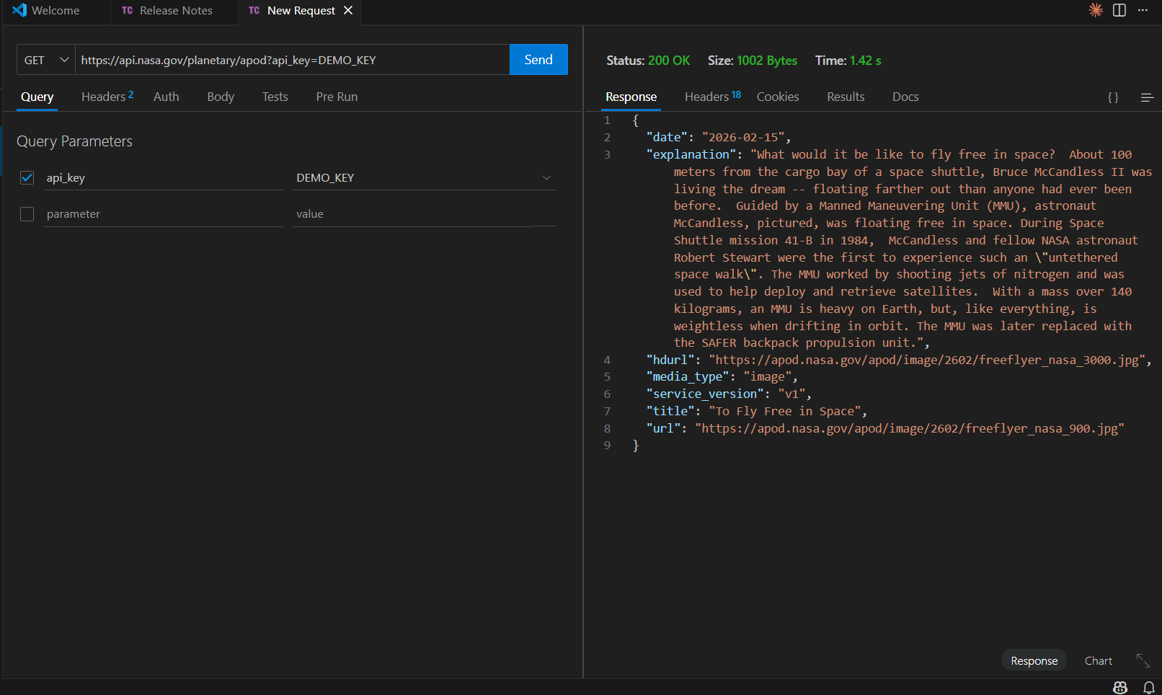
Explanation: Returns the Astronomy Picture of the Day. Status 200 indicates successful retrieval of NASA's daily featured content.
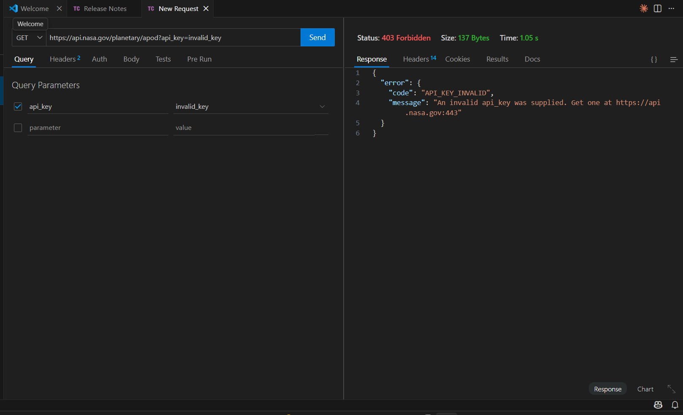
Explanation: Invalid API key returns 403 Forbidden, indicating the request is understood but access is denied due to invalid credentials.
REST Compliance Analysis:
Follows REST Conventions

- Resource-oriented endpoints (/planetary/apod, /mars-photos)
- Query parameters for filtering (date, api_key)
- API key authentication
- Appropriate HTTP status codes (200, 403, 429)
- JSON response format
- Clear documentation and error messages
- Stateless request

Test Case 4 : The Dog API
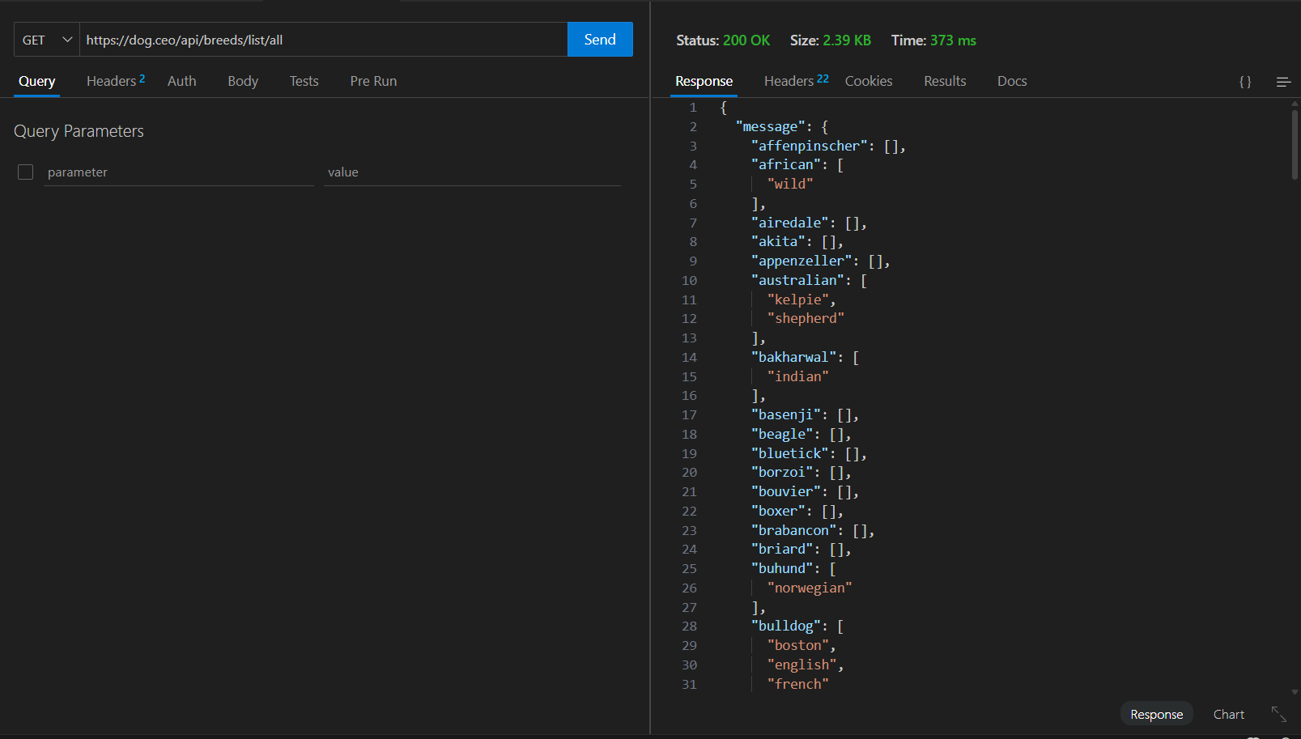

Explanation: This request lists all available dog breeds. The 200 status code confirms success. The response shows breeds as keys, with sub-breeds as arrays. For example, "bulldog" has sub-breeds like "boston", "english", and "french". This hierarchical structure reflects real-world relationships between breeds.
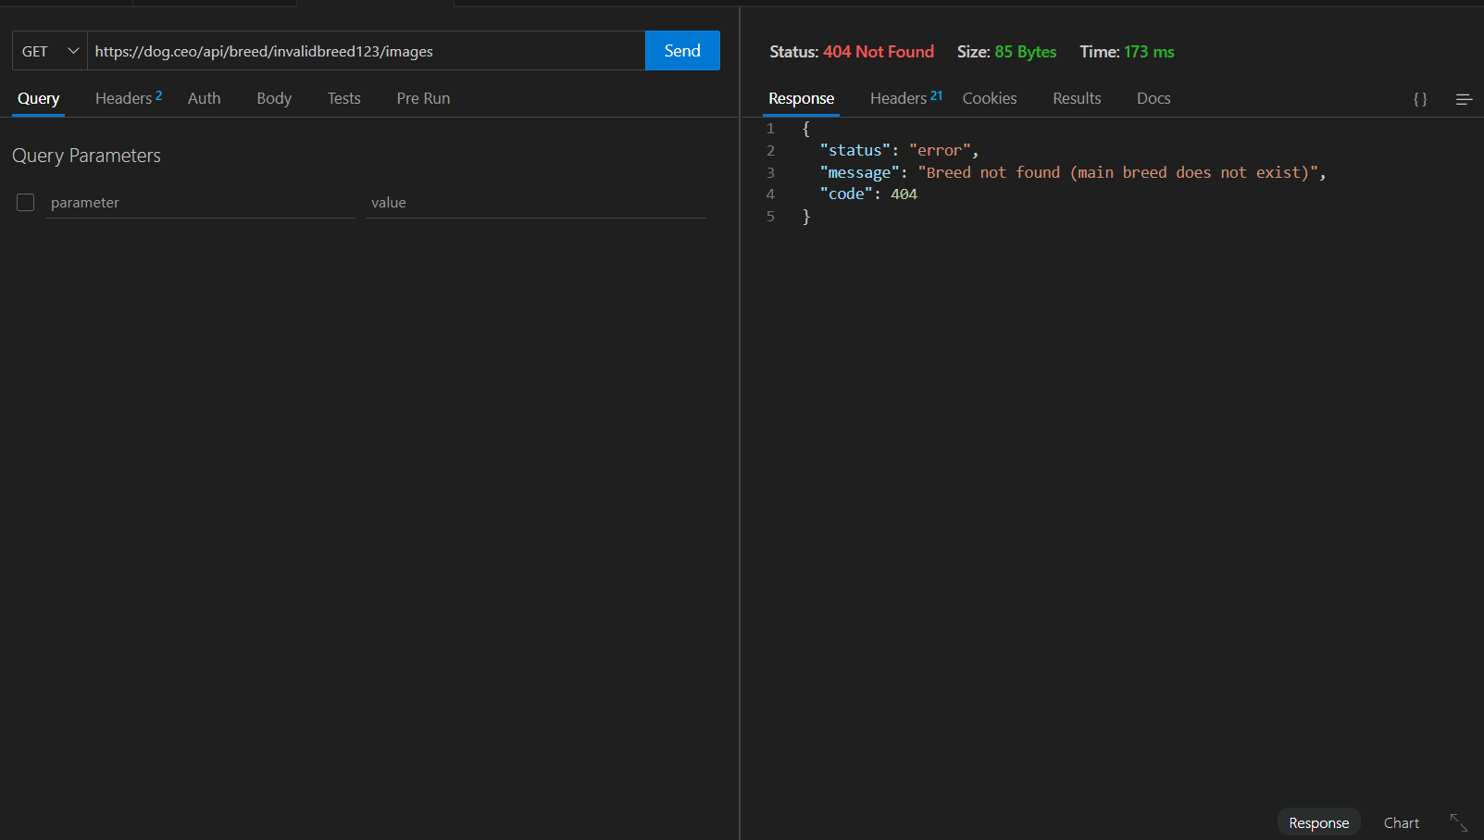
Explanation: This request tries to get images for a breed that doesn't exist. The 404 status code correctly indicates the resource (breed) wasn't found. The API provides a clear error message explaining that the breed doesn't exist, which is good REST practice for error handling.
Does it follow REST conventions? YES
Why it follows REST:

- Resource-Based URLs:
- Standard HTTP Methods:
- Proper HTTP Status Codes:
- Stateless Communication:
- JSON Response Format:
- Hierarchical URI Structure:
- Self-Descriptive Messages:
Test Case 5: Exchange rate API
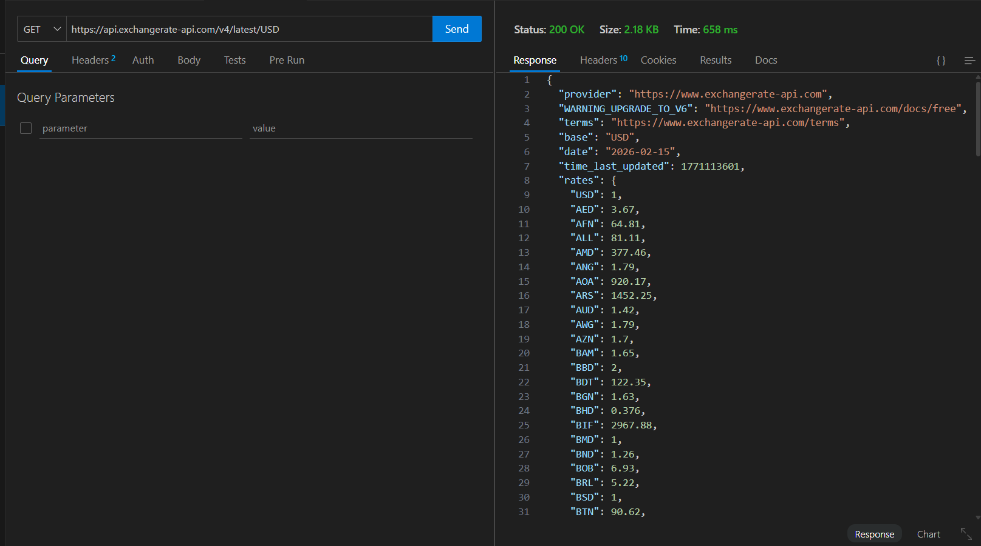
Explanation: This request retrieves the latest exchange rates with USD as the base currency. The 200 status code indicates success. The response shows how much 1 USD equals in other currencies. For example, 1 USD = 0.92 EUR or 30.90 EGP. The "date" field shows when these rates were last updated.
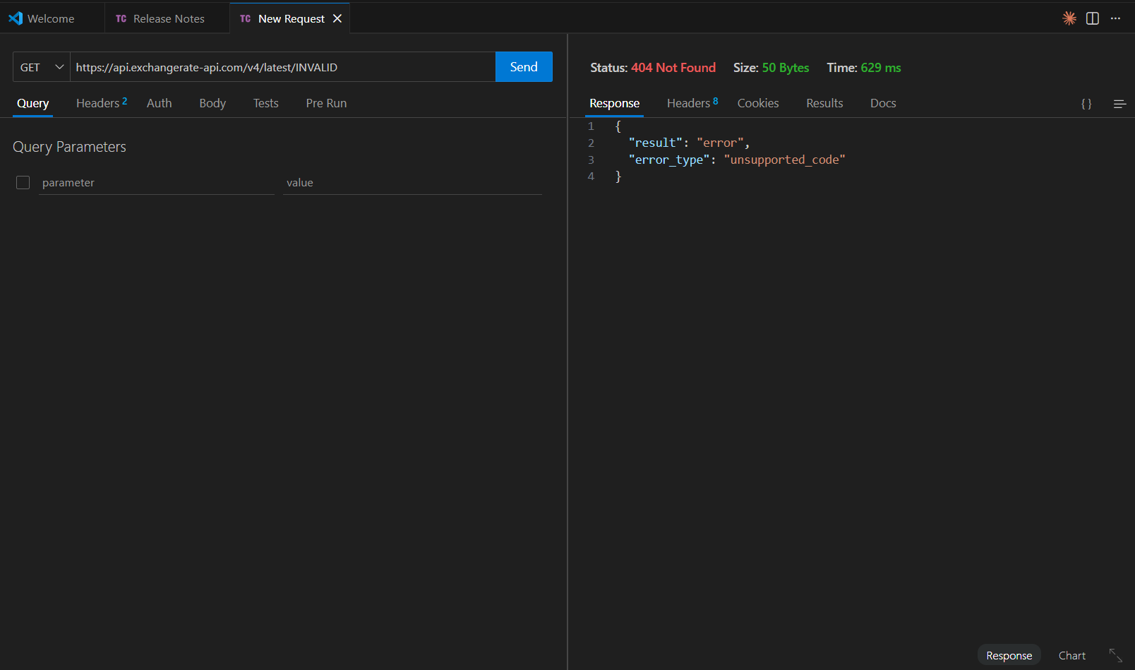
Explanation: This request tries to get rates for an invalid currency code. The 404 status code properly indicates the resource (currency) doesn't exist. The error message clearly states the problem - the currency code is not supported.
Does it follow REST conventions? YES
Why it follows REST:

- Resource-Based URLs:
  - /latest/USD - Latest rates for USD
  - Currency code identifies the resource
  - Clean, predictable URL pattern
- Standard HTTP Methods:
  - Uses GET for data retrieval
  - Appropriate for a read-only data API
  - Correct HTTP verb usage
- Proper HTTP Status Codes:
  - 200 - Successful rate retrieval
  - 404 - Invalid currency code
  - Appropriate status codes
- Stateless Communication:
  - No authentication required
  - No sessions or cookies
  - Each request is independent
- JSON Response Format:
  - Standard JSON structure
  - Consistent format across all requests
  - Easy to parse and use
- API Versioning:
  - /v4/ in the URL
  - Allows future API changes without breaking clients
  - Good version management
- Self-Descriptive:
  - Clear field names (base, rates, date)
  - Timestamp for data freshness
  - Provider and terms URLs included
- Cacheable:
  - Rates are time-stamped
  - Can be cached until time_last_updated changes

REST vs GraphQL Comparison
Feature | REST | GraphQL | Winner
Endpoints | Multiple endpoints (e.g., /users, /posts) | Single endpoint (/graphql) | GraphQL (simplicity)
Data Fetching | Fixed structure (server defines response) | Flexible queries (client chooses fields) | GraphQL (flexibility)
Over-fetching | Common (may return unnecessary data) | Avoided (request only needed fields) | GraphQL
Under-fetching | Common (requires multiple requests) | Avoided (single request gets all data) | GraphQL
Versioning | Uses URL versioning (v1, v2) | Uses schema evolution (no versions needed) | GraphQL
HTTP Status Codes | Uses full range (200, 404, 500, etc.) | Usually returns 200 with errors in body | REST
Caching | Easy using HTTP caching | Complex, requires custom caching | REST
Learning Curve | Easy to learn and use | Moderate to hard | REST
Documentation | External documentation (Swagger, docs) | Self-documenting schema | GraphQL
File Uploads | Native support | Requires additional configuration | REST
Real-time Support | Requires separate WebSockets | Built-in subscriptions support | GraphQL
Tooling | Mature tools (Postman, curl, Thunder Client) | Modern tools (GraphiQL, Apollo) | REST (maturity)
Browser Support | Full support without extra tools | Often requires client libraries | REST
Best Use Case | Simple CRUD, public APIs | Complex applications, mobile apps | Depends on use case

